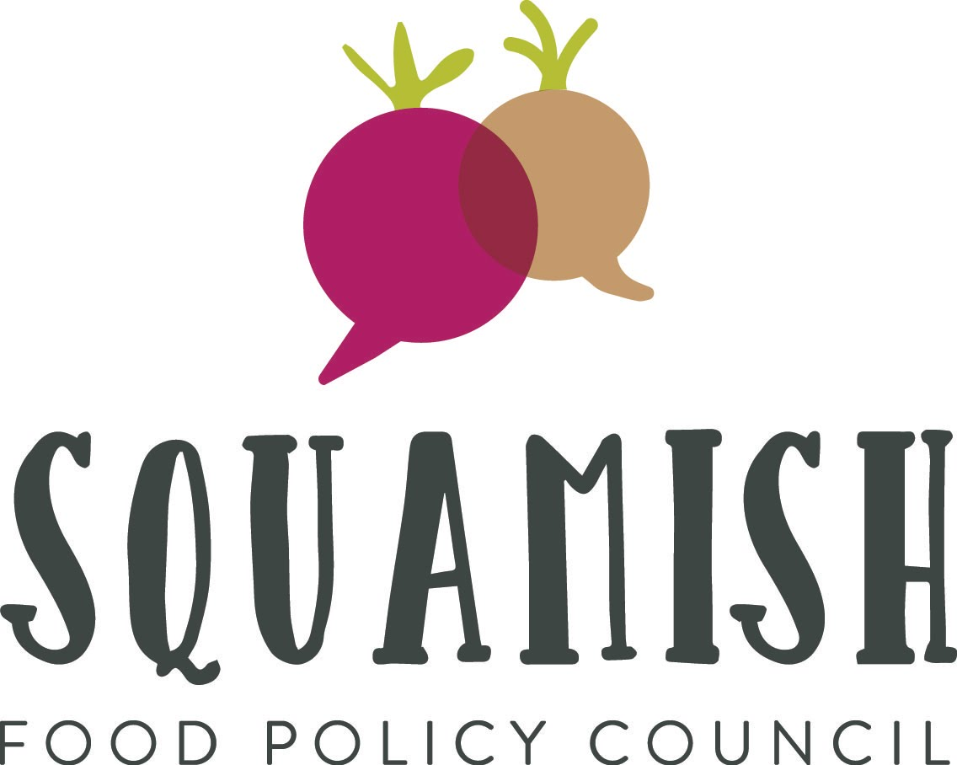

Squamish Food Policy Council Membership Application
Due: Tuesday, January 9th, 2018

Our mission is that ALL members of Squamish have access to enough nutritious, safe, ecologically sustainable, and culturally appropriate food at all times.

Purpose
The Squamish Food Policy Council (SFPC) advises and makes recommendations to the District of Squamish Council, Mayor, and Staff and the Squamish Lillooet Regional District on food issues in Squamish. Recommendations can range from program development to policy changes and implementation that all support to improve our local food system in Squamish.

We are comprised of community members across a wide spectrum of food related industries/sectors (i.e. individuals, nonprofits, and for profit). We function as a bridge between citizens and civic officials, coming together to advance municipal food policy and initiatives that benefit all Squamish citizens. The SFPC meets regularly to discuss and make recommendations to affect changes to current policies, facilitate new policy development related to the food system, hear presentations by community groups and experts engaged in food issues, educate residents, stimulate dialogue, initiate projects and partnerships, and have a good time while doing it.

Membership
- The Council has nine voting members. Members are selected through an application process to ensure that diverse viewpoints are represented. Successful applicants are selected by the membership committee. The seven sectors that ideally would be represented are: Food Production, Processing, Retail, Waste, Access, First Nations, and School District 48. The remaining two members are members at large and may represent any aspect of the food system.
- Terms of office for voting members are three years, with one-third turnover per year (this means that during the first three years, some members will need to have one or two year terms).
- Voting members can hold up to two terms.
- The Council has non-voting members/liaisons from the District of Squamish and Vancouver Coastal Health. These members are serve has liaisons to attend by their respective organizations.
- Quorum for meetings is two-thirds.
- The cost of membership is $5.00 (sliding scale, or can be waived by discretion of the chair).
- The Council makes decisions by consensus (i.e, “I can Live with that”).
- Members of the general public are encouraged to attend all of our meetings, which will be announced publicly.

Please complete this online application by Tuesday, January 9th 2018. Please note that we will be announcing our membership at our January, 17th meeting (6:30-8:30pm at Aligned Collective 201-38085 2nd Ave).

Name:
Telephone number:
Email Address:
Physical Address (must be within District of Squamish or SLRD Area D):
Occupation (optional):
Employer (optional):

Please mark the categories below in which you have direct experience or expertise.

Governmental
- Health
- Education

Food Sector
- Commercial Farming
- Homesteading
- Processing
- Retailer
- Restaurant
- Distributors
- Waste management

Stakeholders / Community
- Community food initiatives (emergency or otherwise)
- Youth
- Indigenous
- Environment
- Community Foundation
- Economic Development
- Real Estate

If you have marked more than one category above, please indicate which ones best represent your role on the Council by ranking them in order, with 1 being the strongest.
1.
2.
3.
4.

Please explain how your expertise and experience makes you a suitable candidate for the food policy council.

Why would you like to serve on the Squamish Food Policy Council?

Have you made contributions to enhancing our food systems in Squamish or surrounding region (Squamish to Lillooet)? If yes, please explain how.

Please explain how you will report back and receive input from your constituency (group you represent)?

Food Policy Council members are appointed for a term of 3 years, except for the inaugural Council, where terms will be a mix of 1, 2 and 3 year terms in order to ensure that they are staggered and that there is adequate continuity on the Council. (The Membership Committee will determine the length of each member’s term at the end of the year.) Please indicate your preference for length of term:
- 1 year
- 2 years
- 3 years

Please provide a brief (no more than 150 words) biography of yourself.

Please provide two references of individuals who can speak to your suitability as a candidate for the Food Policy Council.

Name:
Phone Number:
Email:
Relationship:

Name:
Phone Number:
Email:
Relationship:

Declaration:
I understand that the Squamish Food Policy Council members are appointed for a
term of 3 years* with the possibility of one renewal. If appointed to the Council, I will be
available to serve the full term.
- I understand that the Squamish Food Policy Council will meet up to 8 times per year and that I will do my best to attend all meetings. Note that members may miss no more than two meetings in a calendar year without obtaining leave of absence from the Policy Council.
- I give permission to the Membership Committee to contact me for more information, as
- necessary, about my application.
- I give permission to the Membership Committee to contact the provided references about my application to sit on the Council.
- I understand that the biography I have provided in this application may be used in
- promotional materials of the Squamish Food Policy Council if I am selected to become a member.

Please complete the online form or send the completed application to michalinahunter@gmail.com no later than January 9th, 2018. Thank you for your interest!

*With the exception of the inaugural Council, where terms will be a mix of 1, 2 and 3 year terms
in order to ensure that they are staggered and that there is adequate continuity on the Council.

